Appendix A. Seismic events location with the advance of the working face

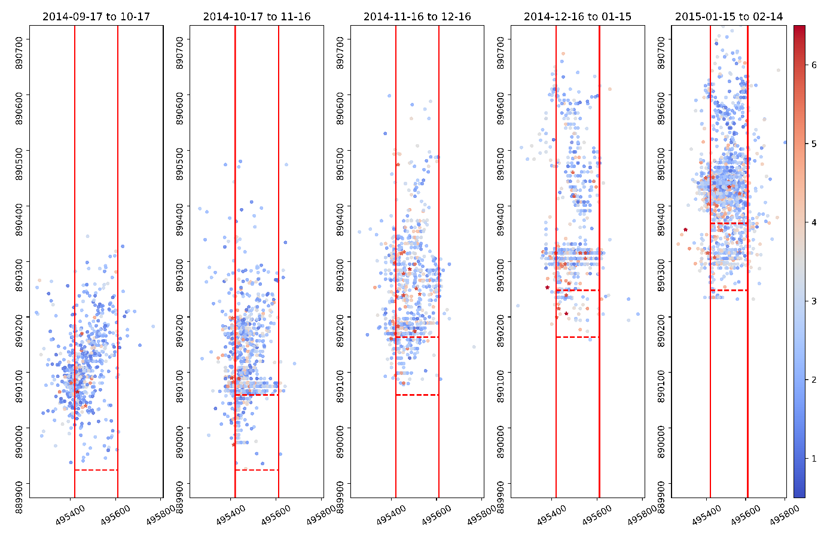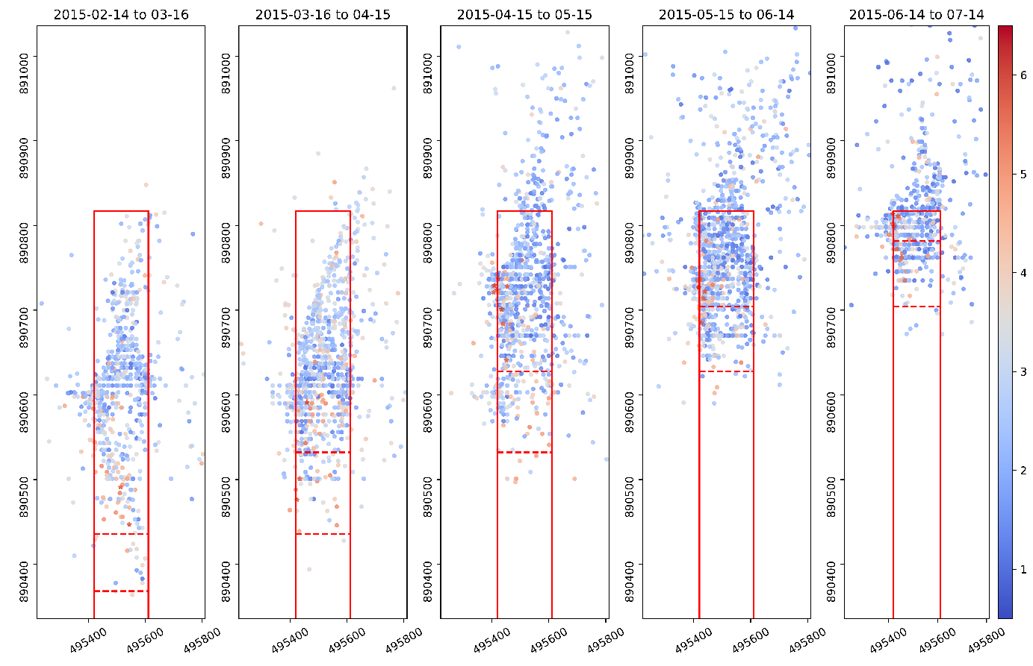
Fig. A1. Monthly evolution of seismic events spatial distribution in LW110 over the monitoring period. The two dashed lines in each figure indicate the start and the end of the working face over the specified period.

Appendix B. Analysis on the impact of energy uncertainty

We appreciate that, as a basic parameter to assess the interactions among seismic events, seismic energy can be very uncertain. This is highly related to the network configuration and coverage concerning the orientation of the tectonic structures that radiate the energy during seismic rupture. To investigate how energy uncertainty may affect the correlation analysis results and whether bias would be introduced if seismic input data contain inherent uncertainties, a 50% variation was added to the seismic energy data (each energy is changed into a random value within ±50% of its original value, following a Gaussian distribution). Fig. A2 presents the correlation results calculated using the proposed three methods. Fig. A2 a and b show that the seismic events with and without energy uncertainty have very similar ACF values and almost identical SOF-time from ACF. Fig. A2 c and d indicate that a slight difference of sill and nugget is shown when considering energy uncertainty. The change of SOF-time is less than 1 day, and thus the SOF-time from the semivariogram remains the same value. Fig. A2 e and f also indicate a very similar MI value. The results in Fig. A2 demonstrate the energy uncertainty of seismic events will cause limited impact on the correlation results.

Fig. A2. Correlation analysis results using the ACF method on (a) raw seismic energy data and (b) seismic energy considering uncertainty; the semivariogram method on (c) raw seismic energy data and (d) seismic energy considering uncertainty; the Moran’s I method on (e) raw seismic energy data and (f) seismic energy considering uncertainty.

