Appendix A. Seismic hazard estimation at the tunnel location

A.1. Magnitude–frequency distributions at the seismogenic sources of interest
The study considers the effect of two seismogenic sources on the examined metro tunnel:

- The San Ramon fault, a reverse NS striking crustal fault, part of the Inner Forearc in the Andean Cordillera (Armijo et al., 2010), which spans for ∼30 km just a few kilometres east to Santiago. Its present-day seismic activity is clustered at around 10 km depth, 20-25 km east of Santiago (Santibáñez et al., 2019), while conservative estimates consistent with rupture of the entire fault length with a hypocenter approximately at 15 km depth may yield events of magnitude M6.9–7.4 (Armijo et al., 2010).
- An L = 350 km part of the subducting Nazca plate, opposite the coastal region of Valparaiso, since the majority of large magnitude events that have been recorded in Chile during the past 70 yr are characterized as interplate thrust subduction earthquakes, with their epicentre off the coast of Chile (Barrientos et al., 2004).

The sources are highlighted with red lines in the maps of Fig. A1. The recorded seismicity for the past 50 yr in the vicinity of the sources (blue or white dots in the maps of Fig. A1) was downloaded from the IRIS online earthquake browser (IEB; ds.iris.edu/ieb). Due to the short duration of instrumental observations relative to the duration of most seismic cycles (instrumental observations span a maximum of 100 yr for a region, while the average recurrence intervals of late Quaternary active faults are generally 1000–10,000 yr), the occurrence rate of certain magnitude earthquakes in a region is often represented by the empirical Gutenberg-Richter law (Gutenberg and Richter, 1944, 1956). The latter comprises a magnitude-frequency relation that correlates the earthquake magnitude $M$ with the mean annual rate of exceedance $λ_{m}$ of this magnitude at a given region. As pointed out by several studies (Anderson and Luco, 1983; McGuire and Arabasz, 1990; Kagan, 2002), simple considerations of the finiteness of the seismic moment flux or the deformational energy capacity call for a magnitude cut-off to the Gutenberg–Richter power relation. The present study adopts the bounded Gutenberg–Richter distribution proposed by McGuire and Arabasz (1990):
$λ_{m}= exp⁡(2.30259a) \frac{exp\left[-β\left(M-M_{o}\right)\right]-exp\left[-β\left(M_{max}-M_{o}\right)\right]}{1- exp\left[-β\left(M_{max}-M_{o}\right)\right]}$ $(M_{o} ≤M≤M_{max})$ (A1)
where $β=2.30259b$, $M_{o}$ is the minimum earthquake magnitude of the dataset, $M_{max}$ is the maximum moment magnitude that a source can produce, and $a$ and b are the constants.
The equation overlays the original Gutenberg–Richter law at lower magnitudes but falls off exponentially above a ‘corner magnitude’, determined by $M_{max}$. In the ensuing, the magnitude–frequency distributions for the San Ramon fault and the examined part of Nazca plate are estimated, fitting the bounded Gutenberg–Richter model to the seismic events of each source. The process comprises the following steps:

- The events are sorted based on magnitude: n number of earthquakes of magnitude $M$ (discrete number), and $N$ number of earthquakes of magnitude larger than $M$ (cumulative number) are calculated.
- The mean annual rate of exceedance λ_{m} is estimated by dividing each $N$ by the monitoring period $T$ = 50 yr for the occurred earthquakes in the vicinity of each source.
- When not known, $M_{max}$ is estimated based on the scaling law of Wells and Coppersmith (1994). The latter calculates the maximum magnitude as
$M_{max}=κ+μ{\log_{10}{(SRL)} }$ (A2)
where $κ$ = 5, $μ$ = 1.22 for reverse faults and $SRL$ is the surface rupture length. The maximum moment magnitude for San Ramon Fault is calculated as $M_{max}$ = 6.8 based on Eq. (A2) (where $SRL$ = 29.2 km, measured as the total fault length from the ‘Hazardous Crustal Fault Database’ provided by the SARA project (Costa et al., 2003; https://sara.openquake.org/hazard_rt2). For the assumed part of the Nazca plate, the maximum moment magnitude is associated with the largest seismic event recorded by this source, i.e. the $M$8.0 Valparaiso earthquake.

According to the results of Fig. A1a, the San Ramon Fault can produce $M$ ≥ 4.5 events with a return period (interevent time) of $T_{r}$ = 1/$λ_{m}$ = 12.9 yr, while the L = 350 km part of the subduction zone is capable of producing $M$ ≥ 7.0 events with interevent time $T_{r}$= 21 yr (Fig. A1b). The interevent time $T_{r}$ represents the interval between two consecutive earthquake events above a certain magnitude threshold. The mean annual rate of exceedance $λ_{m}$ may be converted into time-dependent Poisson probability (Stein et al., 2006) using the relation $P=1-(e^{-λ_{m}t})$, which calculates the probability of exceedance in the next $t$ years. The equation yields 99.9% and 99.2% probability of exceedance in $t$ = 100 yr for $M$ ≥ 4.5 events at the San Ramon fault and $M$ ≥ 7.0 events at the Nazca plate, respectively. A plausible deterministic life-cycle earthquake scenario is adopted to assess the metro tunnel, corresponding to a sequence of high probability $M$4.5 and $M$7.0 events that could repeatedly occur during the lifetime of the structure.

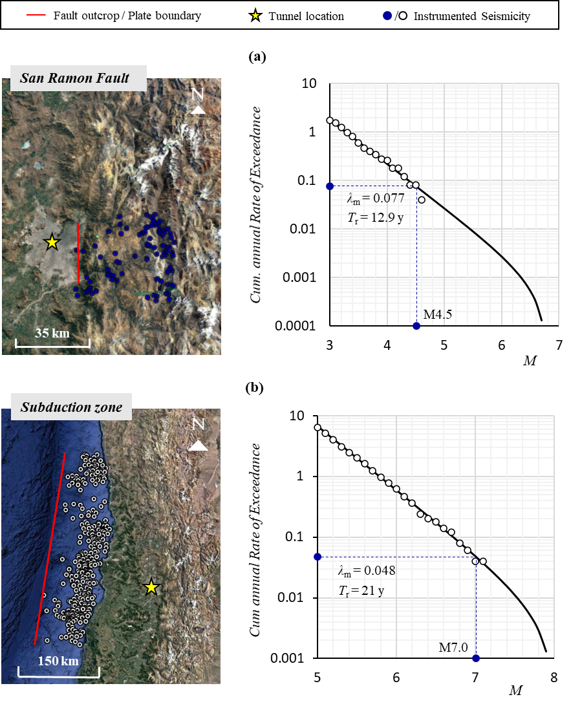
Fig. A1. Snapshots of instrumented seismicity for the past 50 years at the seismogenic sources of interest (IRIS online earthquake browser) and graphs of magnitude–frequency distribution following the bounded Gutenberg–Richter distribution for (a) the San Ramon fault and (b) a 350 km part of the subduction zone. The tunnel location is highlighted on the map.

A.2. Representative ground motion intensity at the tunnel location
Distinct sets of ground motion models (GMMs) are published in the literature to predict ground motions produced by active crustal regions or subduction zones (Douglas, 2019). As indicated by several studies (e.g. Youngs et al., 1988; Crouse, 1991), ground motions generated by subduction earthquakes are substantially larger than those from shallow crustal earthquakes at distances greater than 50 km from the earthquake rupture.
To predict the ground motion intensity at the tunnel area stemming from a $M$4.5 event at the San Ramon Fault, the study employs the GMMs developed by the PEER NGA-West2 Ground Motion Project (Abrahamson et al., 2014; Boore et al., 2014; Campbell and Bozorgnia, 2014; Chiou and Youngs, 2014). The models (abbreviated as ASK14, BSSA14, CB14 and CY14) are globally applicable for shallow crustal earthquakes in tectonically active regions. The average of the four GMMs is considered to estimate the desired intensity measure (i.e. the spectral acceleration).
For estimating ground motion intensity stemming from a $M$7.0 interface event at the subduction zone, the study employs the average value stemming from the Youngs et al. (1997) and Zhao et al. (2006) models. The former applies to worldwide subduction zone interface and intraslab earthquakes of moment magnitude $M$ > 5.0 and distances of 10-500 km from the source, while the latter is more generic, applying both to crustal and subduction zone earthquakes.
Fig. A2 illustrates the acceleration spectra predicted by the selected GMMs for an $M$7.0 event (T_{r} = 21 yr) at the subduction zone and a $M$4.5 event (T_{r} = 12.9 yr) at the San Ramon Fault. The attenuated peak ground accelerations (PGAs) reaching the tunnel site in Santiago equal 0.075g and 0.06g for the $M$7.0 and $M$4.5 events, respectively. The quite low value of the resulting PGA for the $M$7.0 event is related to the motion attenuation due to the large distance from the source and the soil conditions prevalent at the tunnel site. Based on the tunnel location, the respective distance to the earthquake source ($R$) was taken equal to 5 km and 95 km for the San Ramon fault and the subduction zone, respectively. Hard soil conditions were assumed at the reference site, corresponding to NEHRP Site Class C (Holzer et al., 2005), with shear wave velocities ranging between 360 < $V_{s,30}$ ≤ 760 m/s. This is in accordance with the properties of the gravel layer reported in the geotechnical investigations, as the derived earthquake records will be applied to this layer during subsequent numerical analyses.

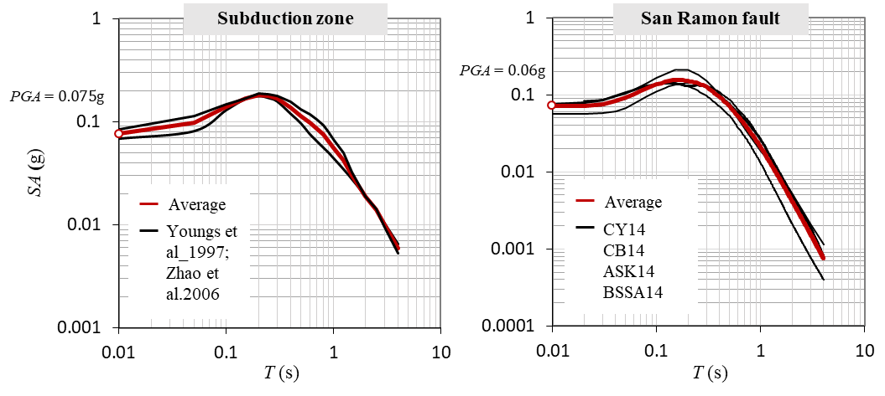
Fig. A2. GMM spectra for a M7.0 event (T_{r} = 21 yr) at the subduction zone (left) and a more frequent M4.5 event (T_{r} =13 yr) at the San Ramon fault (right).

Appendix B. Constitutive relations of the employed soil model

The evolution of stresses in the employed soil kinematic hardening model is described by the following equation:
$σ=σ_{o}+a$ (B1)
where $σ_{o}$ corresponds to the stress at zero plastic strain, and $a$ is a backstress parameter. The latter determines the kinematic evolution of the yield surface in the stress space through a function $F$ where
$F=f\left(σ-a\right)-σ_{o}$ (B2)
with $f\left(σ-a\right)$ being the equivalent Mises stress with respect to the backstress $a$. The plastic flow rate follows an associated flow rule:
${\dot{ε}}^{pl}={\dot{\overline{ε}}}^{pl}\frac{∂F}{∂σ}$ (B3)
where ${\dot{\overline{ε}}}^{pl}$ is the equivalent plastic strain rate.
The evolution law consists of a nonlinear kinematic hardening component and an isotropic hardening component. The former controls the translation of the yield surface in the stress space, and the latter defines the size of the yield surface as a function of plastic deformation (Gerolymos and Gazetas, 2005). The evolution of the kinematic hardening component is described as
$\dot{α}=C\frac{1}{σ_{ο}}\left(σ-a\right){\dot{ε}}^{pl}-Γα{\dot{ε}}^{pl}$ (B4)
where $C$ is the small-strain elastic soil modulus ($E_{o})$ and $Γ$ is a parameter determining the rate at which the kinematic hardening decreases with plastic deformation. At large plastic strains, when $σ$ approaches the maximum yield stress $σ_{y}$, the magnitude of $a$ becomes equal to $a_{s}=C/Γ$ and $\left(σ-a\right)$ tends to $σ_{o}$.
The soil shear strength predicted by the model is pressure-dependent. As such, the yield stress $σ_{y}$ is defined as a function of the mean principal stress $σ_{m}=(σ_{1}+σ_{2}+σ_{3})/3$, the friction angle $φ$ and cohesion $c$ ($σ_{1}$, $σ_{2}, σ_{3}$ correspond to the principal stress components). The yield circle lies between two hypothetical circles: one that circumscribes the Mohr-Coulomb shaped hexagonal pyramid in the π-plane (compressive meridian matching) and one that inscribes the hexagonal pyramid (tensile meridian matching). A user subroutine is incorporated in Abaqus, relating the model parameters to $σ_{m}$ as follows:
$σ_{y}-σ_{ο}=0.5 \left(1-a\right)\left[\left(\frac{6sinφ}{3-sinφ}σ_{m}+\frac{6ccosφ}{3-sinφ}\right)+\left(\frac{6sinφ}{3+sinφ}σ_{m}+\frac{6ccosφ}{3+sinφ}\right)\right]$ (B5)
Parameter $σ_{ο}$, which controls the initiation of nonlinear behaviour, is defined as fraction of the maximum yield stress $σ_{y}$:
$σ_{o}=λ σ_{y}$ (B6)

Appendix C. Supporting data for the calculation of corrosion initiation time and corrosion-induced mass loss percentage

C.1. Corrosion initiation time
The apparent diffusion coefficient $D_{app,C}$ for the calculation of the time to chloride-induced corrosion initiation $T_{corr}$ is calculated as (fib, 2006):
$D_{app,C}= k_{e}D_{RCM,0}k_{t}A(t)$ (C1)
where $k_{e}$ is the environmental transfer variable:
$k_{e}= exp\left[b_{e}\left(\frac{1}{T_{ref}}-\frac{1}{T_{real}}\right)\right]⁡$ (C2)
In Eqs. (C1) and (C2), $b_{e}$ is the regression variable for temperature, with mean and standard deviation values of 4800 K and 700 K, respectively; $T_{ref}$ is the standard test temperature that can be taken as 293 K; $T_{real}$ is the temperature of the structural element or the ambient air that can be determined using the available data from the nearest weather station; $k_{t}$ is the transfer variable equal to 1; $D_{RCM,0}$ is the initial apparent diffusion coefficient; and $A(t)$ is the ageing parameter, calculated as
$A\left(t\right)={\left(\frac{t_{0}}{t}\right)}^{m}$ (C3)
where m is the ageing exponent; and $t_{0}$ is a reference point of time, equal to 0.0767 yr (i.e. 28 d). The values for the parameters involved in the diffusion process are tabulated in Table C1, based on fib (2006) recommendations. As observed, the apparent diffusion coefficient ($D_{app,C})$, which accounts for the rate at which chloride ions can diffuse through the concrete pores, is a function of both time and temperature. To prevent continuous decrease with time, the study accounts for the effects of hydration on concrete diffusivity, considering a hydration period (completion of hydration) after which $D_{app,C}$ no longer declines (Bentz and Tomas, 2001). Based on the derived $D_{app,C}(t)$ curve for a hydration period of 10 yr, an average value of $D_{app,C}$ = 252.2 mm²/yr is assumed. It is noted that the hydration period may range based on environmental temperature and concrete properties. A realistic hydration period value is selected herein to result in a calculated initiation time for corrosion within the range indicated by similar studies on the seismic performance assessment of corroded RC structures (e.g. Ghosh and Padgett, 2010).

C.2. Corrosion-induced mass loss percentage of tunnel reinforcement
In order to calculate the time-dependent percentage $l(t)$ of mass loss of corroded reinforcement at time $t$ after corrosion initiation (Eqs. (7) and (8)), the time-dependent average corrosion penetration depth $P_{ave}(t)$ is calculated as (Afsar Dizaj et al., 2018):
$P_{ave}\left(t\right)=κ \int_{T_{corr}}^{t}{i_{corr}\left(t\right) dt}$ (C4)
where $i_{corr}\left(t\right)$is the corrosion current density at time $t$ after corrosion initiation in μA/cm² and $κ$ is the conversion factor from μA/cm² to mm/yr. The corrosion current density may be estimated as follows (Vu and Stewart, 2000):
$i_{corr}\left(t\right)=0.85 i_{corr0}{(t- { T}_{corr})}^{-0.29}$ (C5)
$i_{corr0}={37.8 {(1-w/c)}^{-1.64}}/X$ (C6)
where $i_{corr0}$ is the corrosion current density at corrosion initiation time ${ T}_{corr}$, $w/c$ is the water-cement ratio of concrete, and $X$ is the thickness of the concrete cover. The values for the parameters involved in the equations are based on fib (2006) recommendations and are listed in Table C1.

Table C1. Parameters involved in the chloride diffusion process.
Variable | Value according to fib (2006)
X (cover depth) (mm) | 50
Ageing exponent, m | 0.2
Depth of convection zone, Dx (mm) | 0
Chloride content at depth Dx, C_{s,Dx} | 2.1
Initial Apparant diffusion coefficient, D_{RCM,0} (m²/s) | 1.58 × 10⁻¹¹
Critical chloride concentration, C_{crit} | 0.6
Initial chloride content in cement pasta, C_{o} | 0
Regression variable, b_{e} (K) | 4800
Reference temperature, T_{ref} (K) | 293
Transfer variable, k_{t} | 1
Reference time, t_{o} yr (28 d) | 0.0767
Temperature of structural element, T_{real} (K) | 294
Water to cement ratio, w/c | 0.5
Pitting coefficient, a | 4
Conversion factor, κ | 0.0116

References

Abrahamson, N.A., Silva, W.J., Kamai, R., 2014. Summary of the ASK14 ground motion relation for active crustal regions. Earthq. Spectra 30(3), 1025-1055.
Anderson, J.G., Luco, J.E., 1983. Consequences of slip rate constraints on earthquake occurrence relations. B. Seismol. Soc. Am. 73(2), 471-496.
Armijo, R., Rauld, R., Thiele, R., Vargas, G., Campos, J., Lacassin, R., Kausel, E., 2010. The West Andean thrust, the San Ramon fault, and the seismic hazard for Santiago, Chile. Tectonics 29(2).
Barrientos, S., Vera, E., Alvarado, P., Monfret, T., 2004. Crustal seismicity in central Chile. J. S. Am. Earth Sci. 16(8), 759-768.
Bentz, E.C., Thomas, M.D.A., 2001. Life-365 service life prediction model and computer program for predicting the service life and life-cycle cost of reinforced concrete exposed to chlorides. User Manual, Version, 2.
Boore, D.M., Stewart, J.P., Seyhan, E., Atkinson, G.M., 2014. NGA-West2 equations for predicting PGA, PGV, and 5% damped PSA for shallow crustal earthquakes. Earthq. Spectra 30(3) 1057-1085.
Campbell, K.W., Bozorgnia, Y., 2014. NGA-West2 ground motion model for the average horizontal components of PGA, PGV, and 5% damped linear acceleration response spectra. Earthq. Spectra 30(3), 1087-1115.
Chiou, B.S.J., Youngs, R.R., 2014. Update of the Chiou and Youngs NGA model for the average horizontal component of peak ground motion and response spectra. Earthq. Spectra 30(3), 1117-1153.
Costa, C., Cisneros, H., Machette, M.M., Dart, R.L., 2003. A new database of Quaternary faults and folds in South America. ILP Task Group II-2 (western Hemisphere). In: Proceedings of the American Geophysical Union, Fall Meeting 2003, abstract #T31C-0854.
Crouse, C.B., 1991. Ground-motion attenuation equations for earthquakes on the Cascadia subduction zone, Earthq. Spectra 7,210-236.
Douglas, J., 2019. Ground motion prediction equations 1964-2019. http://www.gmpe.org.uk/.
Ghosh, J., Padgett, J.E., 2010. Aging considerations in the development of time-dependent seismic fragility curves. J. Struct. Eng. 136(12), 1497-1511.
Gerolymos, N., Gazetas, G., 2005. Phenomenological model applied to inelastic response of soil-pile interaction systems. Soils Found. 45(4), 119-132.
Gutenberg, B., Richter, C.F., 1944. Frequency of earthquakes in California. B. Seismol. Soc. Am. 34(4), 185-188.
Gutenberg, B., Richter, C.F., 1956. Earthquake magnitude, intensity, energy, and acceleration: (Second paper). B. Seismol. Soc. Am. 46(2), 105-145.
Kagan, Y.Y., 2002. Seismic moment distribution revisited: I. Statistical results. Geophys. J. Int. 148(3), 520-541.
McGuire, R.K., Arabasz, W.J., 1990. An introduction to probabilistic seismic hazard analysis. Geotech. Environ. Geophys. 1, 333-353.
IEB. Incorporated Research Institutions for Seismology (IRIS) Earthquake Browser. https://ds.iris.edu/ieb.
fib, 2006. Model Code for Service Life Design. Federation Internationale du Beton, Lausanne.
Santibáñez Boric, I.V., 2019. Crustal faults in the Chilean Andes: Seismotectonic constraints from a combined geological and geophysical approach. PhD Thesis. Pontificia Universidad Catolica de Chile, Chile.
Wells, D.L., Coppersmith, K.J., 1994. New empirical relationships among magnitude, rupture length, rupture width, rupture area, and surface displacement. B. Seismol. Soc. Am. 84(4), 974-1002.
Youngs, R.R., Day, S.M., Stevens, J.P., 1988. Near field motions on rock for large subduction zone earthquakes. In: Earthquake Engineering and Soil Dynamics II, Recent Advances in Ground Motion Evaluation, ASCE Geotechnical Special Publication 20, 445-462.
Youngs, R., Chiou, S.J., Silva, W.J., Humphrey, J.R., 1997. Strong ground motion attenuation relationships for subduction zone earthquakes. Seismol. Res. Lett. 68(1):58-73, Jan/Feb 1997.
Zhao, X., Zhang, J., Asano, A., et al., 2006. Attenuation relations of strong ground motion in Japan using site classification based on predominant period. B. Seismol. Soc. Am. 96(3): 898-913, 2006.

