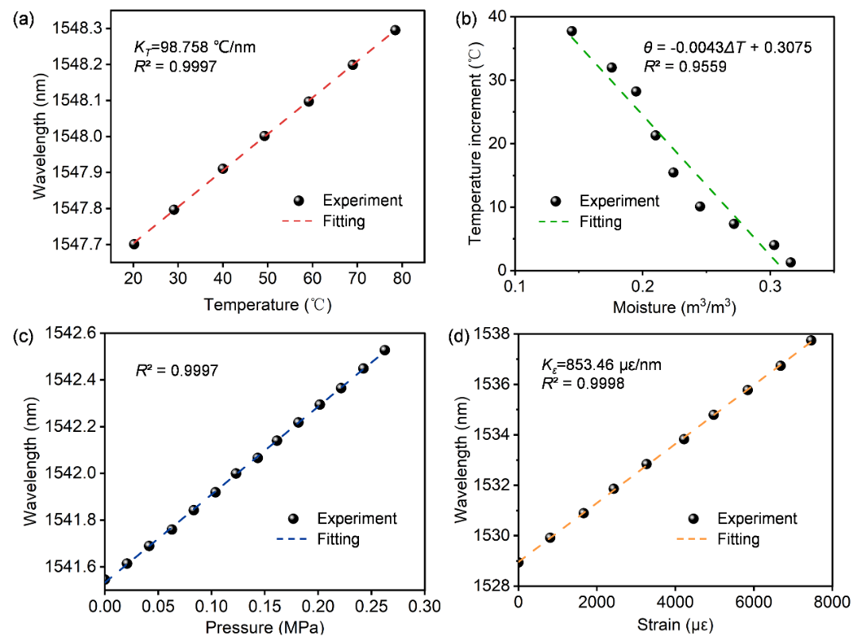

**Fig. S1**. Calibration results of the thermo-hydro-poro-mechanical behavior: (a) Temperature, (b) Moisture, (c) Pore water pressure, and (d) Strain.

**Table S1**. Technical and economic comparisons of UWFBG with FBG and DFOS (Ye et al., 2022).

|  |  |  |  |  |  |  |
| --- | --- | --- | --- | --- | --- | --- |
| Item | DFOS | | | | FBG | UWFBG |
| BOTDRa | BOTDAb | DTSc | OFDRd |
| Strain accuracy (με) | ±50 | ±20 | - | ±1 | ±1 | ±1 |
| Temperature accuracy (°C) | ±1 | ±1 | ±0.2 | ±0.1 | ±0.1 | ±0.1 |
| Spatial resolution (m) | 1 | 0.1 | 1 | 0.01 | - | 1 |
| Measuring distance (km) | 15 | 25 | 10 | 0.07 | - | 2 |
| Sampling resolution (m) | 0.05 | 0.05 | 0.25 | 0.0003 | - | 1 |
| Real-time response* | N | N | N | Y | Y | Y |
| Multiplexing quantity | - | - | - | - | 10 | 2000 |
| Sampling time (s) | >300 | >60 | >60 | 6.5 | 1 | 5 |
| Equipment cost** | M | H | M | H | L | M |

Note: a Brillouin Optic Time Domain Reflectometer; b Brillouin Optic Time Domain Analysis; c Distributed Temperature Sensing; d Optical Frequency Domain Reflection; * Y: Yes; N: No; ** H: High; M: Medium; L: Low